Impact Story:

Empowering Youth Entrepreneurs through the Adwumawura Programme at Takoradi Technical University
At Takoradi Technical University (TTU), the implementation of the Adwumawura Programme continues to demonstrate the transformative power of structured entrepreneurship support in unlocking the potential of young people.
Over the past phase of the programme, TTU successfully delivered intensive entrepreneurship training to 75 enrolled participants, equipping them with practical skills in business development, innovation, and market positioning. The training combined theory with hands-on mentorship, ensuring participants were not only inspired but also capable of translating ideas into viable and scalable business concepts.
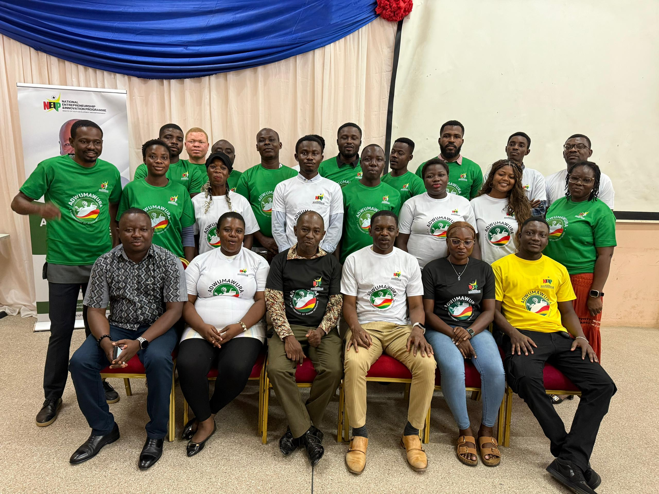
Figure 1 A group picture featuring Adwumawura officials, TTU Facilitators and some selected beneficiaries at TTU Auditorium Conference Room 1

Business Field Visitation
The TTU Innovation Team exceeded programme expectations by undertaking field visits to all 27 businesses that demonstrated resilience by submitting their business concepts. These visits provided an opportunity to assess the current state of each enterprise and deliver tailored technical recommendations.
As a result, many of the businesses implemented improvements that significantly enhanced their operations and contributed to measurable growth. Importantly, this approach ensured that even participants who may not ultimately receive funding still benefited from the programme through strengthened business practices and operational transformation.
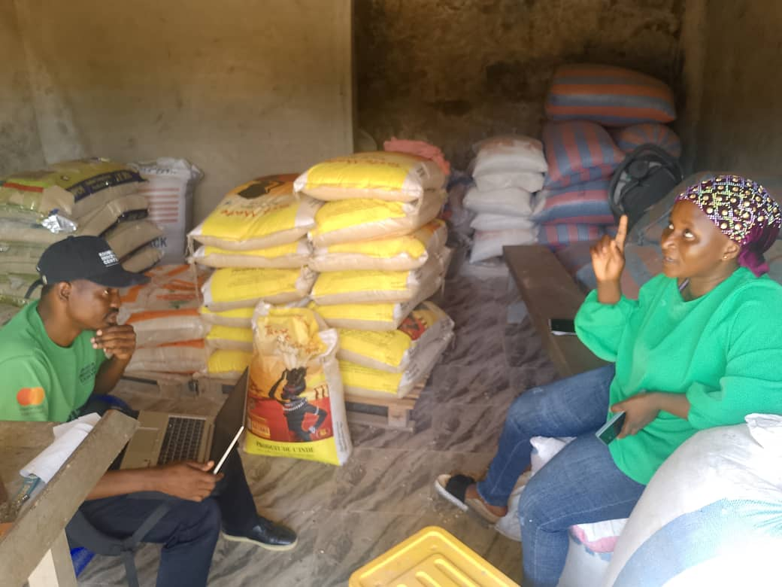
Figure 2 Anthony Agee-kum, TTU Technical Team Member on a site visit to Maria Seidu at her shop, interacting with her on her business
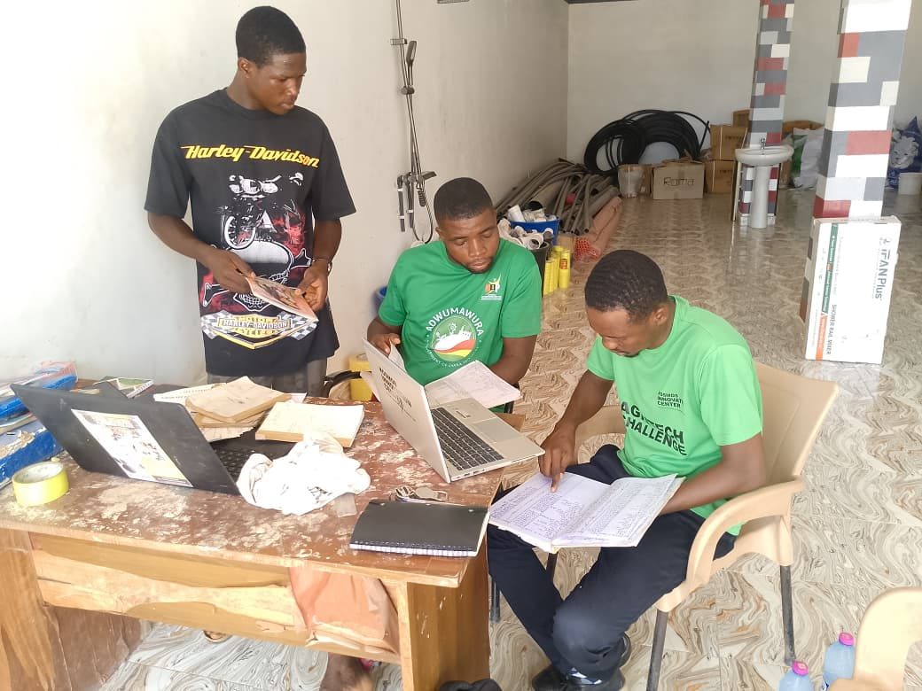
Figure 3 Adwumawura offical from TTU interacting with participant of the Adwumura program upon a site visit, checking record keeping

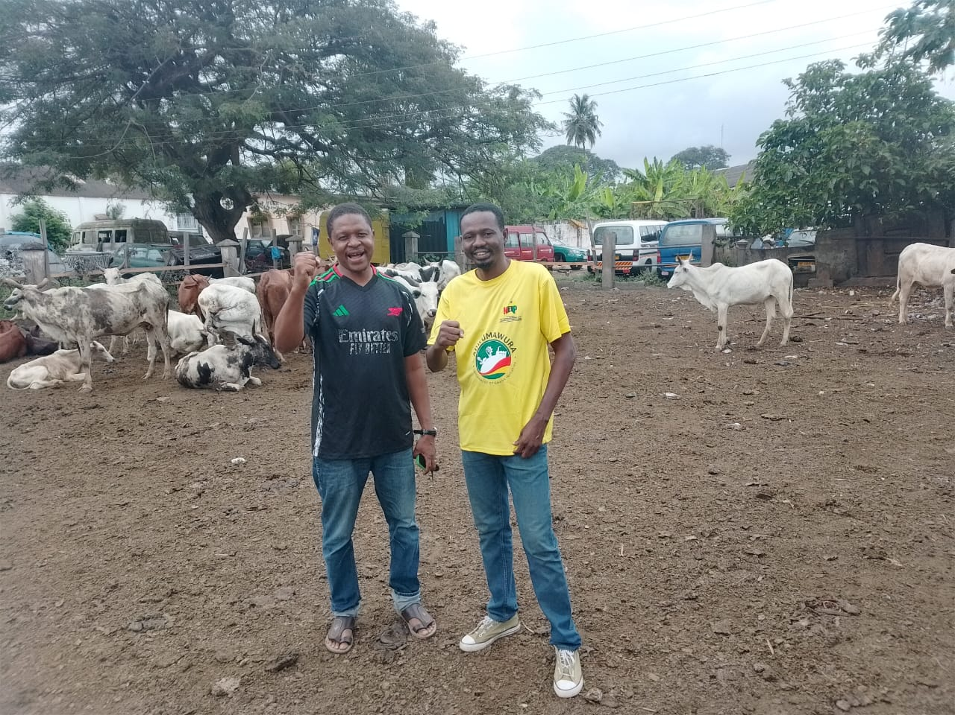
Figure 4 Adwumawura Facilitator from TTU in a post with a a beneficiary at his farm site after interacting with him on a visit
Business Pitching Activities
A major highlight of this phase was the remarkable progress made during the business, pitching and proposal development stage. Through the dedicated technical guidance of the TTU Technical Team, 26 teams successfully developed and submitted complete business proposals.
Beyond proposal development, participating businesses recorded significant improvements across key operational areas, including product branding and packaging, fundraising, pitching, digital presence and visibility, and product development, translating into market expansion and improved sales and revenue.
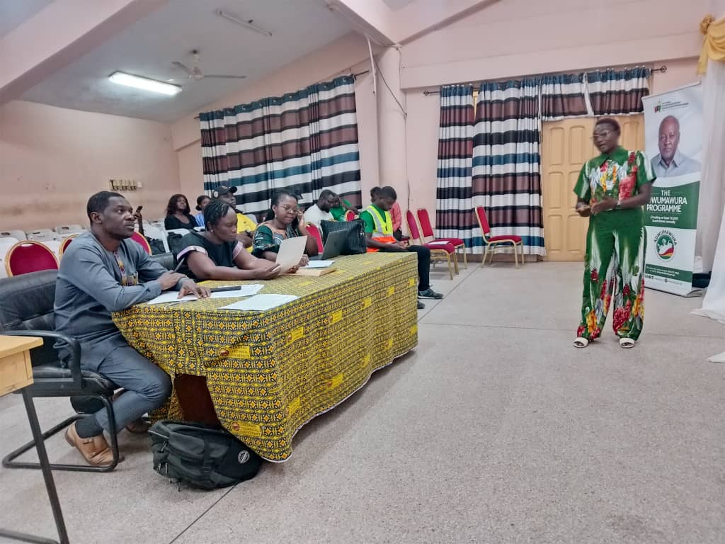
Figure 5 Adwumawura beneficiary pitching his business to TTU judges for feedback and comments
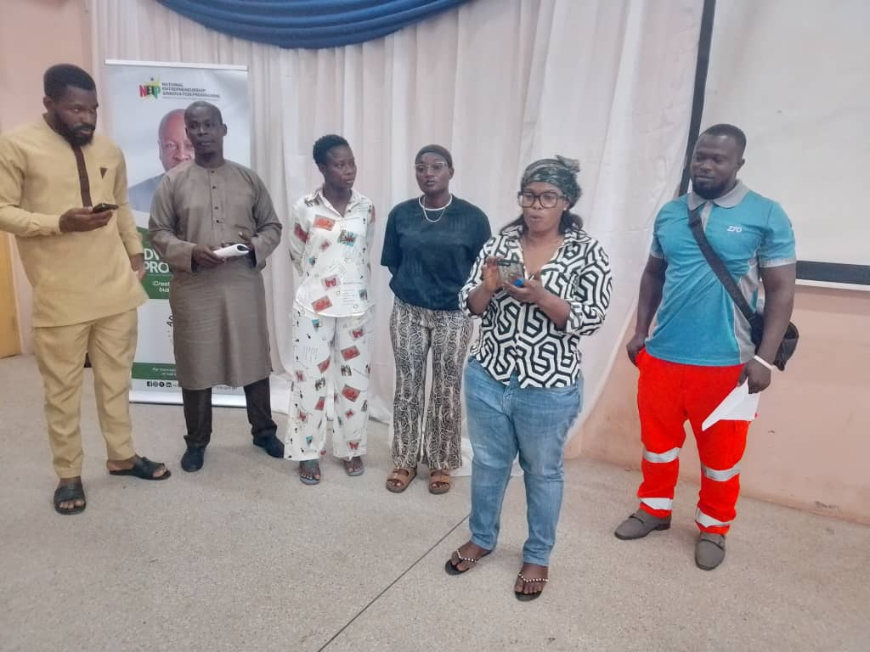
Figure 6 Adwumawura Beneficiaries participating in a group presentation session as part building their presentation skills
Programme Testimony: Maria Seidu’s Transformation Journey
For Maria Seidu, CEO of Mariam Seidu Enterprise, participation in the Adwumawura Programme has been a transformative journey, turning practical training into real business progress.
Through the programme, Maria gained critical knowledge in revenue generation and fundraising strategies, particularly learning how to diversify income streams and leverage accessible funding sources such as support from friends and family as an entry point, while positioning her business to attract more formal financing in the future.
One of the most significant milestones in her journey was developing the confidence and capacity to pitch her business to potential investors. Applying the skills acquired, Maria successfully presented her business to the Adwumawura evaluation team and progressed through the screening process to secure funding support—a major step toward scaling her enterprise.
“The programme has completely changed how I approach my business. I now understand how to structure my revenue streams and confidently present my ideas to investors.”
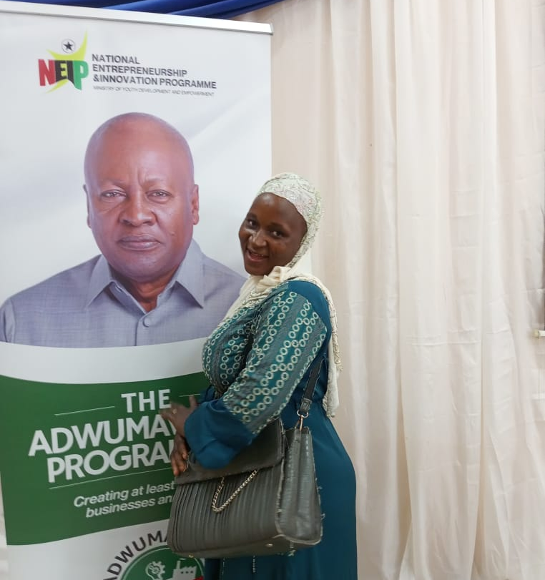
Figure 7 Maria Seidu, Adwumawura beneficiary, posed in an excited mode after sharing her success story
Beyond funding readiness, the programme delivered immediate operational impact. Maria strengthened key aspects of her business, including product branding and record-keeping practices. Previously, limited documentation made it difficult to track performance; however, she now maintains detailed business records, enabling her to monitor revenue, manage costs, and better understand her profit margins.
“I used to run my business from memory, without proper records, but now I document everything. This has helped me clearly track my profits and make better decisions.”
With anticipated funding support, after successfully pitching and being selected, Maria plans to address critical operational challenges such as storage and transportation, positioning her business for improved efficiency and growth.
Maria’s journey reflects the broader impact of the programme—equipping young entrepreneurs not only with knowledge, but with the tools, confidence, and opportunities needed to build resilient and scalable businesses.

Figure 8 Maria Seidu, a beneficiary of the Adwumara programme excited after selected for funding for her business
Even more significant is the transition to the funding stage. 50% of the participating teams progressed to the financial assessment phase, representing one of the highest progression rates among participating hubs in the Western Region of Ghana.
Beneficiary Story: Building Confidence and Brand Identity – Is My Eye Your Eye Media
For the founder of Is My Eye Your Eye Media, the Adwumawura Programme marked a turning point in both personal development and business growth.
Prior to the programme, the business operated informally with limited structure. Through the training and mentorship received, the founder gained the confidence to transition into a more formal and professionally managed enterprise.

A key transformation was the adoption of structured record-keeping practices, enabling better financial tracking and decision-making.
Figure 9 CEO of Is My Eye Your Eye media, beneficiary of Adwumawuraposed in his nicely branded business flyer
The programme also strengthened the founder’s ability to present and pitch the business using storytelling techniques, significantly improving engagement with potential clients and investors.
“I have built my confidence and now understand how to present my business professionally. Storytelling has changed how I pitch. We are now able to connect better with clients and investors.”
Another critical insight gained was the strategic importance of branding:
“Branding is everything; it makes you unique and attracts customers. I now see it as one of the most important investments for my business.” CEO, Is My Eye Your Eye Media.
Progression to Funding Stage
A key milestone of the programme is the transition of participants into the funding stage. Notably, 50% of participating teams progressed to the financial assessment phase, representing one of the highest progression rates among hubs in the Western Region of Ghana.
“Reaching the funding stage is a big milestone for us. It shows that our idea is not just viable, but has real potential to create jobs and impact our community.”

Figure 10 CEO of Mommy's Kitchen, Blessing, middle, in an excited mode with family after being selected for funding in the Adwumawura Programme

Programme Outcomes and Impact
The programme delivered measurable outcomes across multiple dimensions:
- Skills Development: Improved entrepreneurial, leadership, and governance competencies
- Business Readiness: Stronger business models and clearer value propositions
- Market Alignment: Enhanced alignment of business ideas with real market needs
- Pitching Excellence: Improved pitch structure, storytelling, and delivery
- Operational Growth: Strengthened branding, packaging, digital presence, and record-keeping practices
- High-quality pitch outputs, reflecting effective coaching and mentorship
- Strong facilitator–beneficiary collaboration, enhancing learning outcomes
Challenges and Adaptive Measures
Despite its success, the programme faced several constraints, including:
- Limited transport and logistical support
- Resource constraints affecting training delivery
- Limited funding for post-training incubation
To mitigate these challenges, the programme prioritized resource optimization, flexible delivery approaches, and low-cost advisory support strategies, ensuring continued impact despite constraints.
Key Highlights:
- 75 youth trained
- 26 business proposals developed and submitted
- 50% progressed to funding stage
- Improved business performance across branding, packaging, digital visibility, and product
Key Lessons Learnt
- Practical, hands-on learning significantly enhances outcomes
- Early and continuous mentoring improves business readiness
- Integrated pitch coaching strengthens investment potential
- Adequate logistics support is critical for sustained participation
development.

Conclusion and Forward Outlook
The Adwumawura Programme at TTU demonstrates a strong, scalable model for youth entrepreneurship development. Through its integrated approach, the programme has successfully built a pipeline of confident, capable, and investment-ready young entrepreneurs.
With enhanced support for logistics, incubation, and post-training financing, TTU is well-positioned to deepen its impact, scale enterprise development outcomes, and contribute meaningfully to Ghana’s economic transformation.

