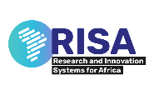

FULL REPORT ON THE IMPLEMENTATION OF THE INNOVATION CLINICS

Facilitators:
Prof. Victor Fannam Nunfam (Lead Facilitator)
Dr. Emefa Akua Amponsah
Prof. Ann Dodor
Ms. Christabel Irene Deha

Institution:

Takoradi Technical University (TTU), acting through the Takoradi Technical University Innovation Hub (TTUiHUB)
Location: Takoradi, Western Region, Ghana
Project Implementation Period: July 2025 – October 2025

OVERVIEW

The Innovation Clinics were implemented by the Takoradi Technical University Innovation Hub (TTUiHUB) between July and October 2025 as part of the RISA–BRIInG initiative. The primary goal was to strengthen the entrepreneurial and technical capacity of community innovators engaged in small-scale yoghurt and food processing businesses under the “Portside Yoghurt” brand.

The clinics were designed as a series of interactive training and mentoring sessions that focused on market access, product development, regulatory compliance, and business sustainability. Through participatory learning, hands-on demonstrations, and guided mentorship, the facilitators sought to equip participants with the knowledge, skills, and practical tools to enhance product quality, expand market reach, and foster inclusive economic growth within the Takoradi innovation ecosystem.

KEY DELIVERABLES
- Conducted one-on-one and group mentoring sessions with community innovators in Takoradi.
- Facilitated two major Innovation Clinics focused on Routes to Market, Branding and Packaging, FDA Reflections, Shared Equipment Model, and Cost Build-Up and Margins.
- Guided innovators to understand product pricing, cost structures, and profit margin analysis to strengthen financial sustainability.
- Supported participants in exploring the shared equipment model to reduce production costs and enhance compliance with regulatory standards.
- Provided orientation on FDA registration requirements, safety standards, and labelling expectations for yoghurt producers.
- Supported innovators to design and improve prototype packaging and branding for Portside Yoghurt.
- Encouraged the use of social media platforms such as WhatsApp, Facebook, and Hubtel for product promotion and customer engagement.
- Documented success stories, challenges, and lessons learned to inform subsequent engagement and support.
- Submitted comprehensive engagement reports, attendance sheets, photographs, and follow-up recommendations.

CLINIC SESSIONS COVERED

1. First Field Visit and Orientation

Date: 10th July 2025
Venue: Pentecost Church Hall, Takoradi
Participants: 23 (6 males, 17 females)
Objectives: Establish direct engagement, identify challenges, and validate mentoring topics.
Key Outcomes: Confirmed capacity gaps and agreed on training priorities.

2. Support Engagement #1 (Innovation Clinic 1)

Date: 14th August 2025
Venue: SSNIT Building, Small Conference Room, Takoradi
Participants: 27 (8 males, 15 females, 4 facilitators)
Topics
- Routes to Market – Prof. Ann Dodor
- Branding and Packaging Linked to Market Needs – Ms. Christabel Irene Deha

Key Activities
- Guided participants on identifying and prioritizing local and regional market opportunities.
- Facilitated discussions on branding, product differentiation, and market-driven packaging.
- Participants reviewed and improved their product packaging designs.

Key Outcomes
- Action plans developed to access new markets.
- 75% of participants improved their product packaging design and presentation.
- Participants demonstrated greater understanding of branding strategies aligned with customer preferences.

3. Support Engagement #2 (Innovation Clinic 2)

Date: 4th September 2025
Venue: SSNIT Building, Small Conference Room, Takoradi
Participants: 17 (5 males, 8 females, 4 facilitators)
Topics
- FDA Reflections – Ms. Christabel Irene Deha
- The Shared Equipment Model – Dr. Emefa Akua Amponsah
- Cost Build-Up and Margins – Prof. Victor Fannam Nunfam

Key Activities
- Discussed the importance of meeting FDA food safety and licensing requirements for small-scale producers.
- Demonstrated the shared equipment model as a cooperative strategy to enhance production efficiency, reduce costs, and ensure consistent product quality.
- Conducted practical exercises on calculating production costs, pricing, and determining profit margins to support sustainability.
- Facilitated group reflections on how the Portside Yoghurt Association could serve as a formal structure for shared equipment management, FDA registration, and collective market access.

Key Outcomes
- Improved understanding of FDA certification procedures and steps for successful product registration.
- Agreement among participants to explore the formalization of a producers’ association to coordinate certification and resource sharing.
- 60% of participants demonstrated the ability to calculate cost components and profit margins for yoghurt production.
- Renewed commitment to sustain production, improve packaging, and use digital platforms (e.g., WhatsApp and Facebook) for product promotion and customer engagement.
- Follow-up assessments scheduled for 28th September 2025 and 7th October 2025 to track implementation progress.

KEY INSIGHTS - MAJOR OBSERVATIONS AND LEARNINGS FROM IMPLEMENTATION
- Participants showed increased appreciation for structured mentorship and practical demonstrations that directly addressed their operational realities.
- Community innovators demonstrated stronger business confidence and commitment to regulatory compliance following the FDA reflection session resulting in acquiring FDA certificate.
- The introduction of the shared equipment model inspired cooperative thinking, resource pooling, and collaboration among innovators.
- Training on cost build-up and margins revealed widespread underestimation of production costs, motivating participants to adopt better record-keeping and pricing strategies.
- The inclusion of digital marketing discussions led to heightened interest in online promotion as a tool for reaching new markets.
- Female innovators remained active leaders and influencers in group decision-making and mentoring others.
- A culture of peer learning and collaboration has begun to emerge among participants, strengthening the sustainability of the innovation ecosystem.

CHALLENGES ENCOUNTERED
- Financial Limitations: Many innovators struggled to purchase raw materials in bulk, affecting production volume and cost efficiency.
- Inadequate Production Space: Lack of a compliant and hygienic production facility prevented participants from meeting regulatory requirements.
- Limited Access to Shared Equipment: Despite enthusiasm for the shared model, participants lacked the necessary resources to acquire and manage shared machinery.
- Knowledge Gaps in Costing and Pricing: Prior to the cost build-up session, most innovators had limited understanding of cost structures, profit margins, and sustainability strategies.
- Low Digital Literacy: Some participants faced challenges using social media effectively for marketing and customer engagement.
- Attendance Constraints: Transportation and logistical challenges occasionally reduced participation rates, particularly among rural innovators.

LESSONS LEARNED - KEY TAKEAWAYS FROM THE PROCESS
- Practical and interactive learning methods such as demonstrations and group exercises yield better outcomes than theory-based sessions.
- The shared equipment approach can help overcome resource constraints and promote collective business resilience if well-coordinated.
- Continuous mentorship fosters consistency, innovation, and accountability among community innovators.
- Cost-awareness and profit-tracking are vital to ensuring sustainability in small-scale production ventures.
- Engagement in digital promotion and social marketing presents new opportunities for expanding local market reach.
- Female participation enhances creativity, teamwork, and community engagement within innovation-driven enterprises.
- The need for the acquisition of markerspace can improve confidence, boost business locations and address, and sustain production of Portside Yoghurt.

RECOMMENDATIONS - WAYS TO BETTER SUPPORT THE BENEFICIARY COMMUNITY AND ENSURE SUSTAINABILITY
- Financial Support: Establish microgrant or revolving fund mechanisms to help innovators purchase inputs in bulk and meet certification costs.
- Regulatory Facilitation: Partner with the FDA and relevant agencies to develop a simplified certification pathway tailored to small-scale producers.
- Acquisition of Shared Equipment Scheme: Support the acquisition of equipment for Portside Yoghurt Association to enhance shared equipment use, quality assurance, and regulatory compliance.
- Production Infrastructure: Develop or allocate a shared, hygienic production or makerspace that meets basic food safety and processing standards. A makerspace can enhance brand visibility, strengthen customer confidence, provide a permanent business location, and ensure the sustainable production of Portside Yoghurt.
- Capacity Building: Continue training on digital marketing, business record-keeping, and cost management.
- Follow-Up and Mentorship: Maintain quarterly follow-up sessions and peer mentorship to ensure implementation of cost and branding improvements.
- Gender and Inclusion: Continue to prioritize women and persons with disabilities in all stages of innovation and enterprise development.
- Market Linkages: Facilitate partnerships with local supermarkets, schools, and social events to expand market access for Portside Yoghurt.

APPENDIX


[Insert Photos]

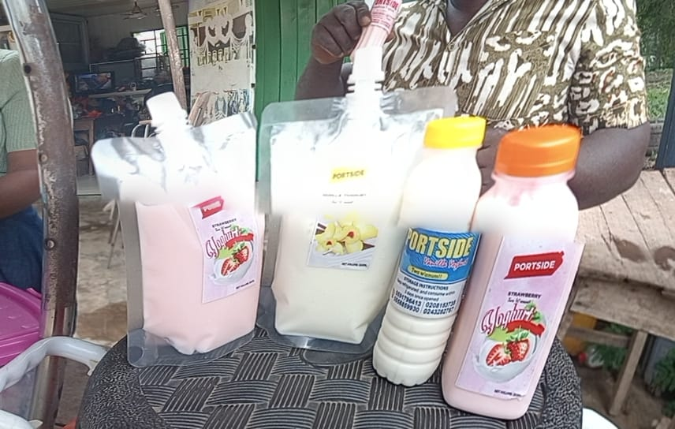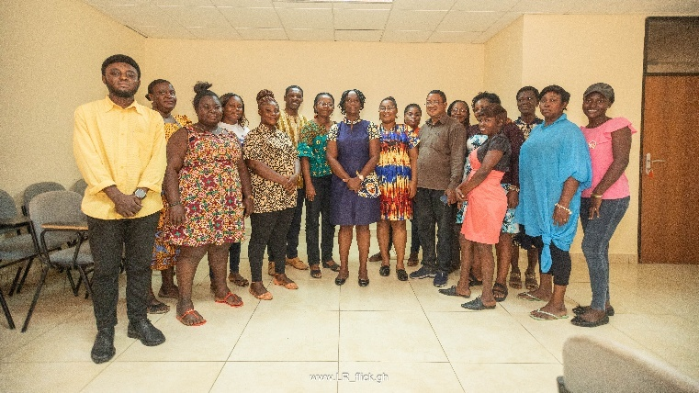

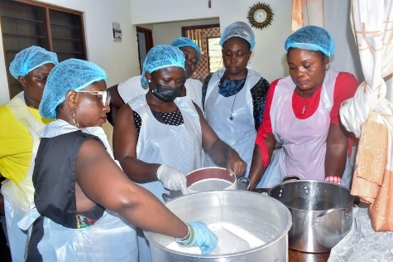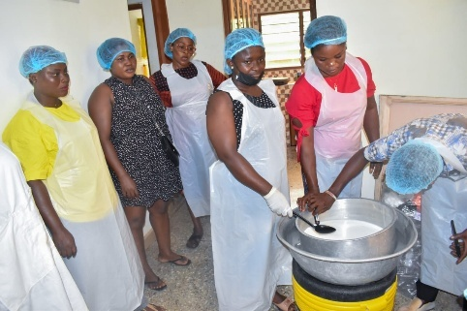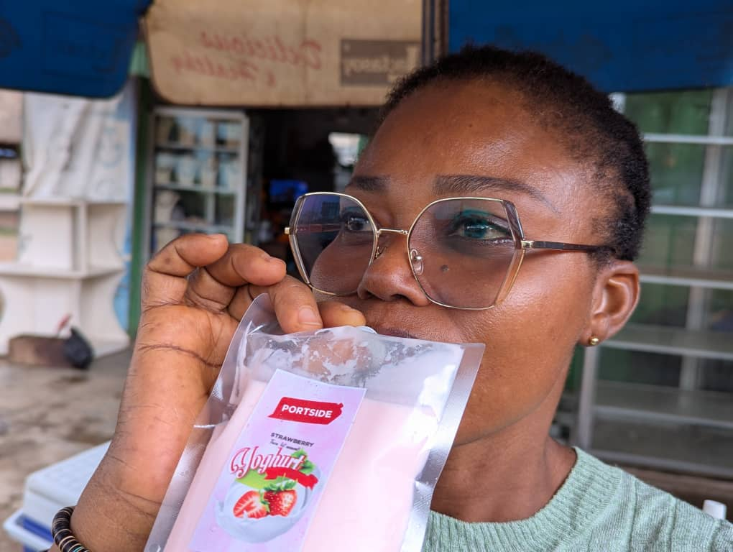

[Insert Attendance Sheets or List]


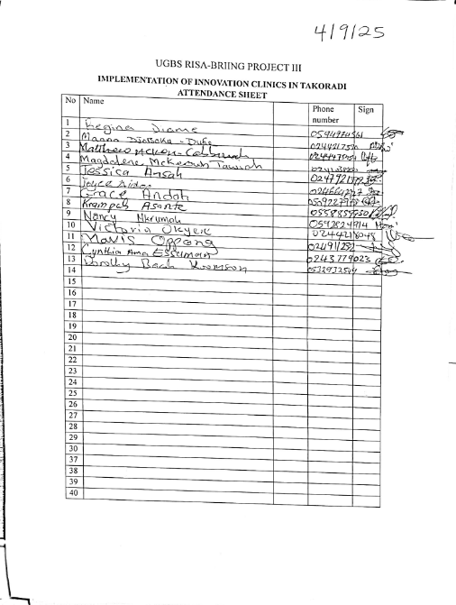

FDA Registration Certificate

